**Final Project Report**

**Application Description**

The application that we created for this class is called “Study Guide”. This app is mostly used for a educational purpose. It allows users to make personalized sets of inputs (questions and answers for a specific topic or subject) and save them on a database. Then they can review whatever they saved by clicking on the review section. Finally, there is also a feature that allows user to relax by having them play a generalized quiz in a gamified fashion.

**Who will it benefit?**

This app is mostly aimed at student from high school and those who’s classes require a lot of memorization.

**Application Design**

**Login Page:**

* Email & Password EditText
* Sign-up & Login Button
* “Forget Password” TextView
* “Number of Attempts Remaining” TextView

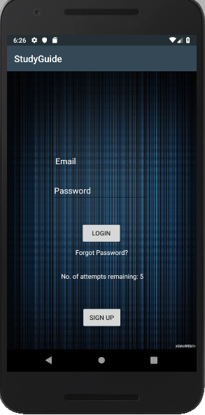

* The login page was initial created to enable the users to personalize their set the way the want to.
* By putting their email and password and hitting on the login button, the user will be sent to the homepage
* Using Firebase Auth, the app will verify if the user has entered the correct password and if the user has verified his email
* The sign-up button will send the user to the sig-up page where they can register themselves
* There is a max number of attempts available to enter the app. And once the counter reaches zero, the login button will be disabled

**Sign-Up Page:**

* Email & Password EditText
* Sign-up Button
* “Already Registered!! Login” TextView

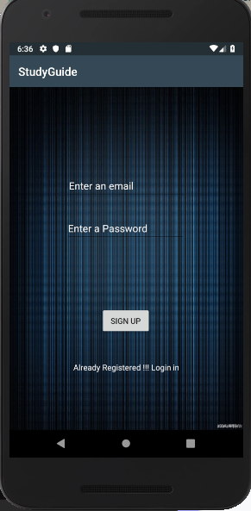

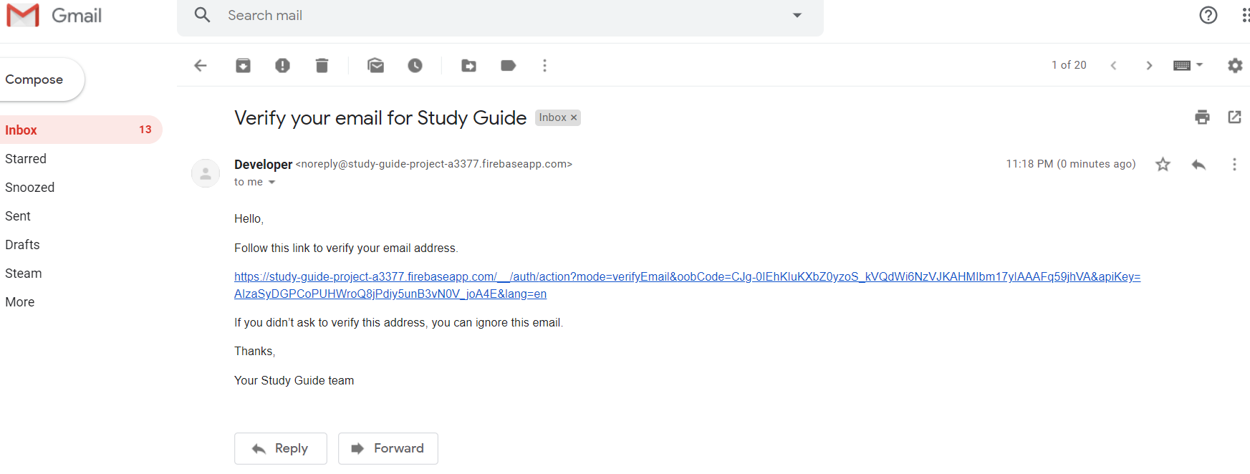

* The sign-up page was created to all new user to join the app
* The user will simply have to enter his/her email and password then hit the sign-up button. This will then send an email verification to that email

**Forget Password:**

* Email EditText
* Reset Button

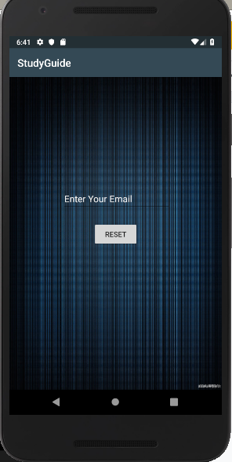

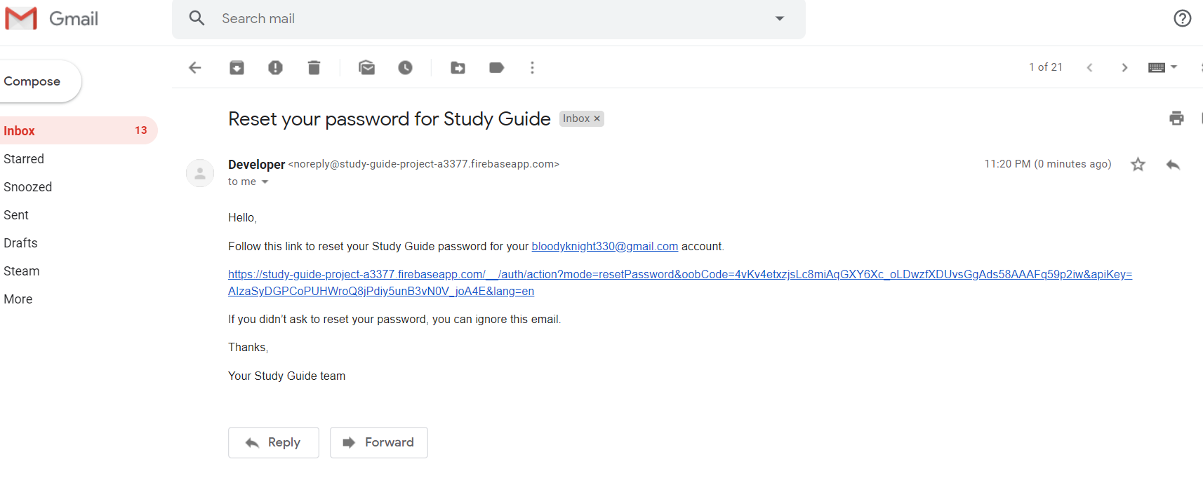

* Here, users who can’t remember their password can change them simply by entering their email and pressing on the “Rest Button”
* Once that is done, an email will a reset link will be sent

**Home Page:**

* Review Button
* Make a Set Button
* Test Yourself Button
* Logout Button

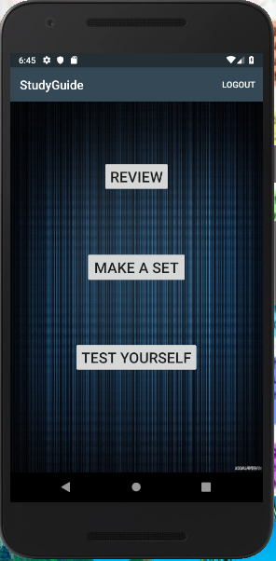

* The homepage is where the button that will send the user to the three features of the app is located
* The “Review” button will send the user to the review activity
* The “Make a Set” button will send the user to the make a set activity
* The “Test Yourself” button will the send the user to the test yourself activity

**“Make a Set” Page:**

* Title EditText
* Question & Answer EditText (Multiline)
* Next Button
* Done Button
* New Set Button

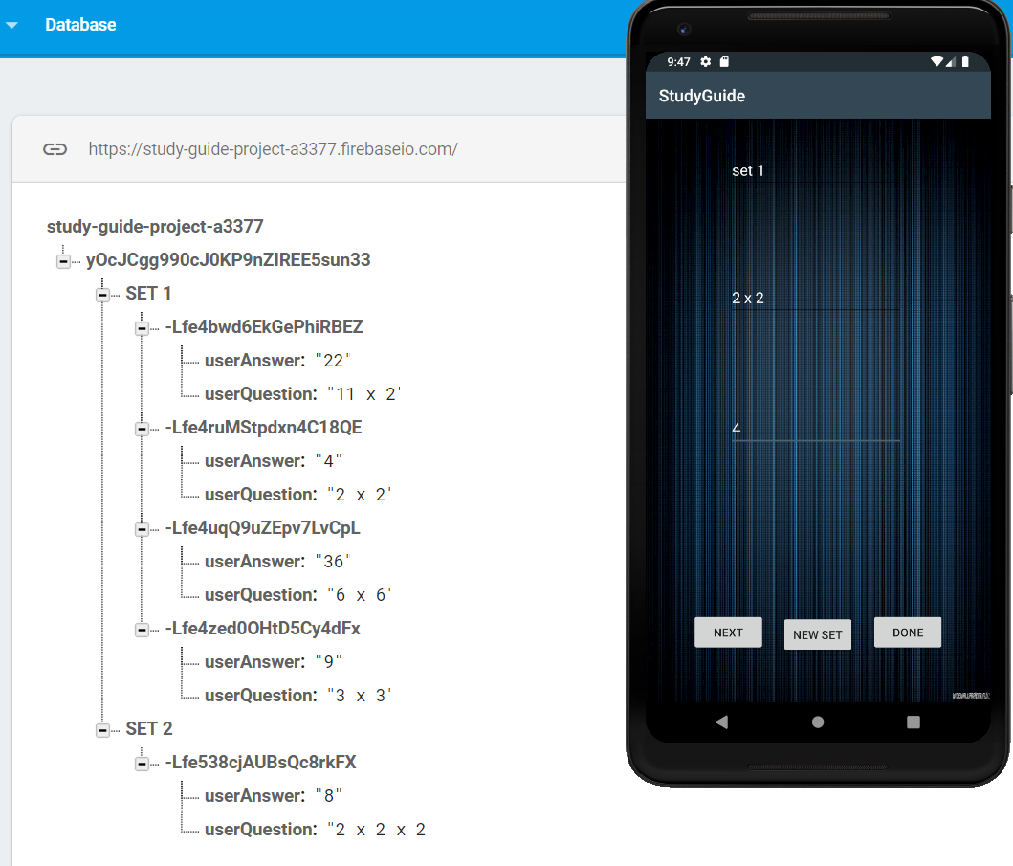

* In here, the user makes the set that they want to save in the database
* All they must do is to enter the title of the set then the answer and question.
* When the “Next” button is clicked, this will tell the app that the user wants to keep writing in the same set
* The new set button will allow the user to create a new set
* The done button will exit out of this activity and send the user back to the homepage and if there is some information when the done button is pressed on, then it will save that information before moving the user to the homepage

**“Review” Page:**

* Enter Button
* “Please Enter the Title” EditText
* TextView

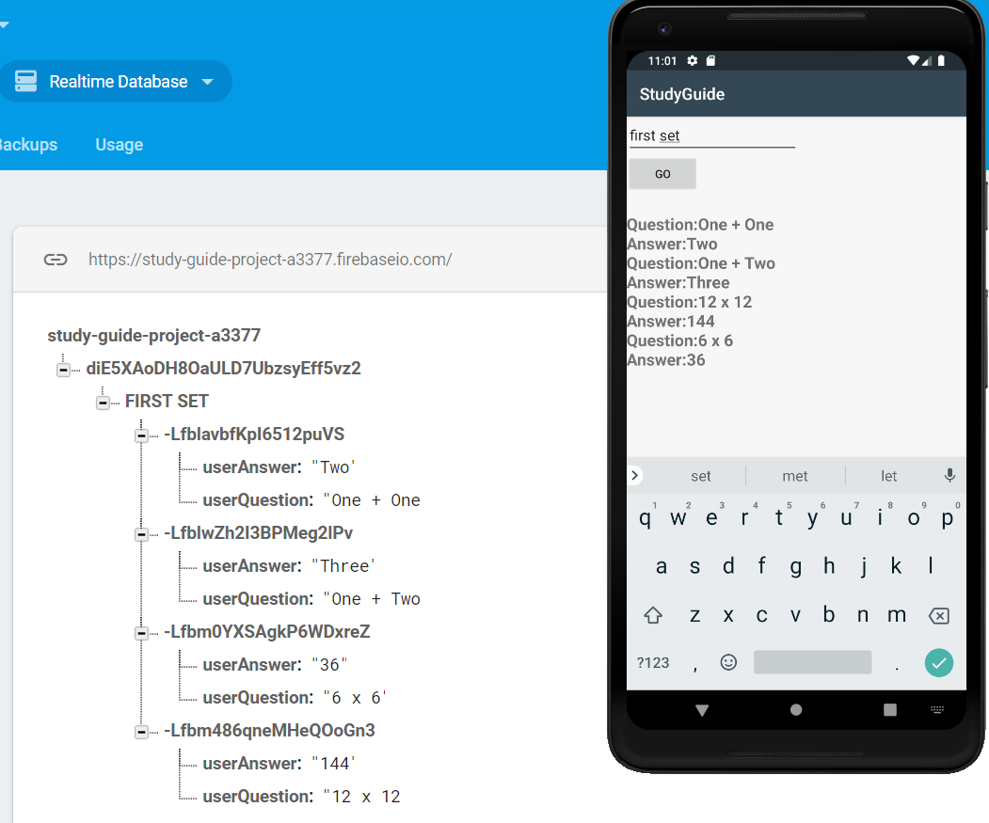

* In here, the user can review the sets that they have created
* By entering the title of the set they wish to review and clicking on “GO”, all the answers and questions of that title will appear in the ListVIew

**“Test Yourself” Page**

* Question
* 3 multiple choice
* Exit Button
* Score

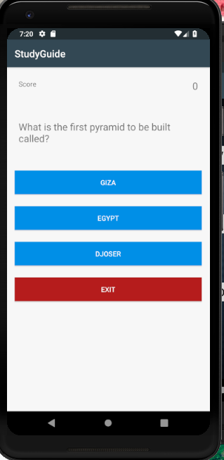

* In here, the user is given a multiple-choice question to stimulate the brains
* For every right answer, the score will go up and a “Toast” saying “Correct” will appear
* For every wrong answer, the score will remain the same and a “Toast” saying “Wrong” will appear
* There is also an Exit option in case the user wants to leave this page

**Application Implementation and Evaluation**

Order of the activities built:

1. Homepage
2. Make a Set
3. Login Page
4. Sign Up Page
5. Test Yourself
6. Forget Password
7. Review

Classes Created:

* Topics Class
* HomePageActivity Class
* MainActivity Class
* QuestionLibrary Class
* ResetActivity Class
* ReviewActivity Class
* SetActivity Class
* SignUpActivity Class
* TestYourselfActivity Class

The application works as intended. During the testing phase some modification were made. Some of them are:

* “Forgot Password” Activity
  + This one was added after most of the project was done.
* “Email Verification”
  + To create an extra layer of protection since most app nowadays have that
* “Done” & “New Set” buttons were added to the “Make a Set” activity
* Change to the functionality of the “Next”, “Done” & “New Set” button in the “Make a Set” activity
  + This was a small modification that had to do with what happens with the inputted text when each button is clicked
  + Also had to make sure that empty sets aren’t created by accidents
* ProgressDialog was added to the login page
  + This was created to enable to the user to see that once the hit the login button, something was happening
  + It also makes the delay for login in understandable

**Thoughts & Experiences**

Overall, it was a fun project. Had we been given more time; we would have edited the way the ‘Review” activity works. The issue that we can see happening with the current design of the review activity is that the user must remember each of the titles of the sets they have written in order to get back their information. What would have been great would be to have all the titles displayed in a stylized fashion when the user hits the review button. Then all he’ll have to do would be to choose the title he/she want to review and click on it. And that should display everything saved under that title